**ADMIN MANUAL**

1. **Manage Staff**
2. **Delete Hash Transcript**
3. **Add Exporter**

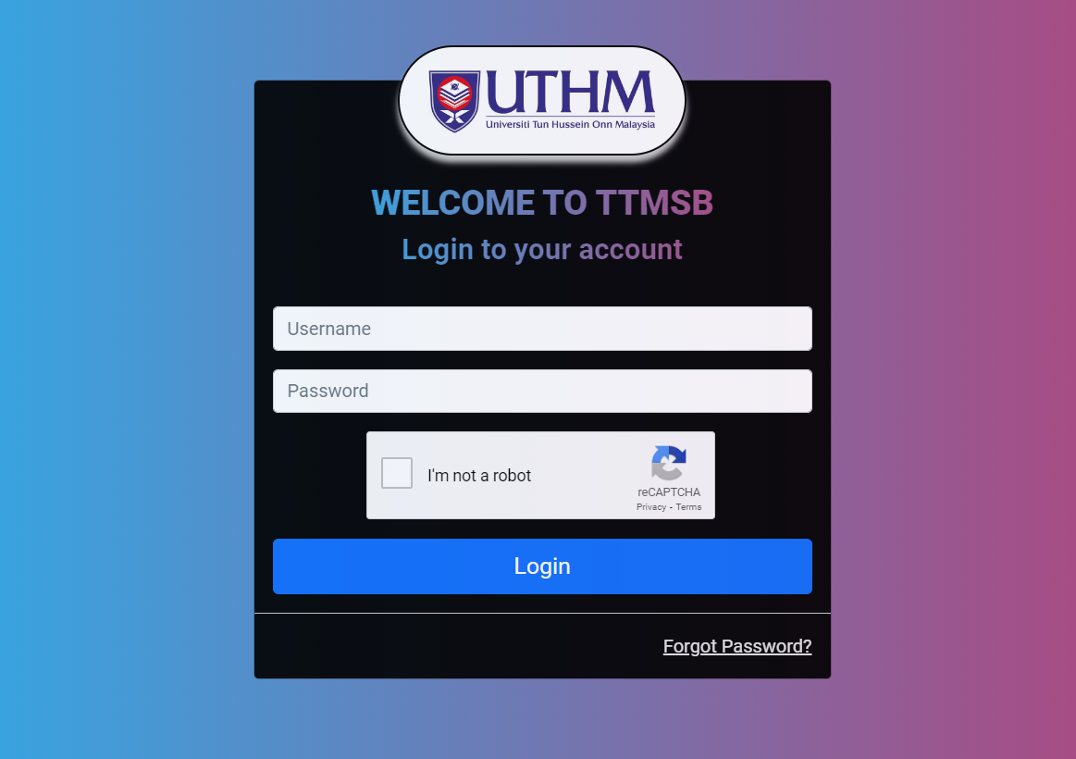

**Admin username Admin@123 default password**

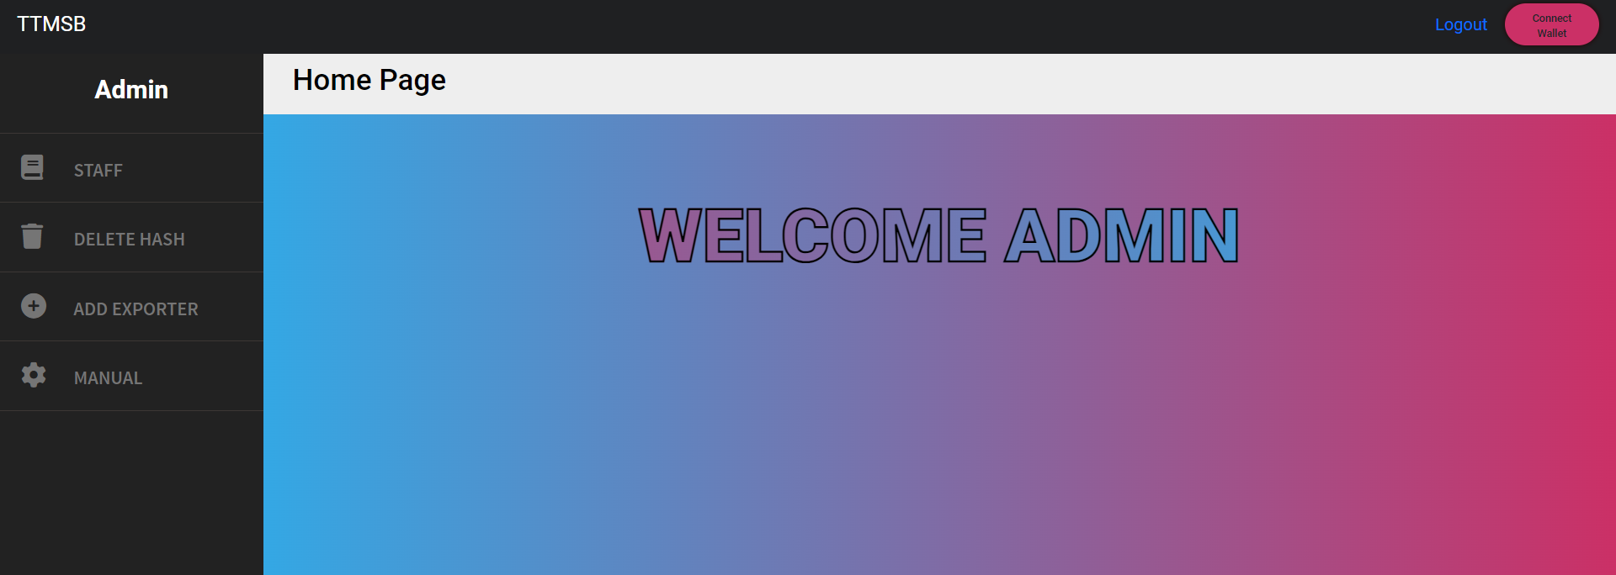

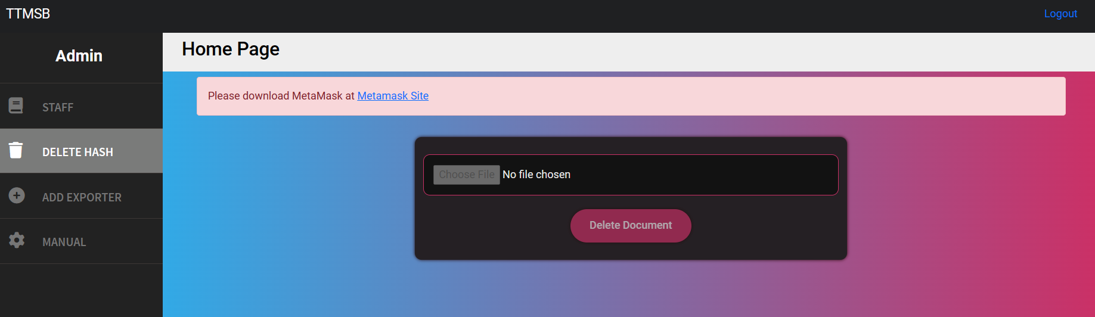

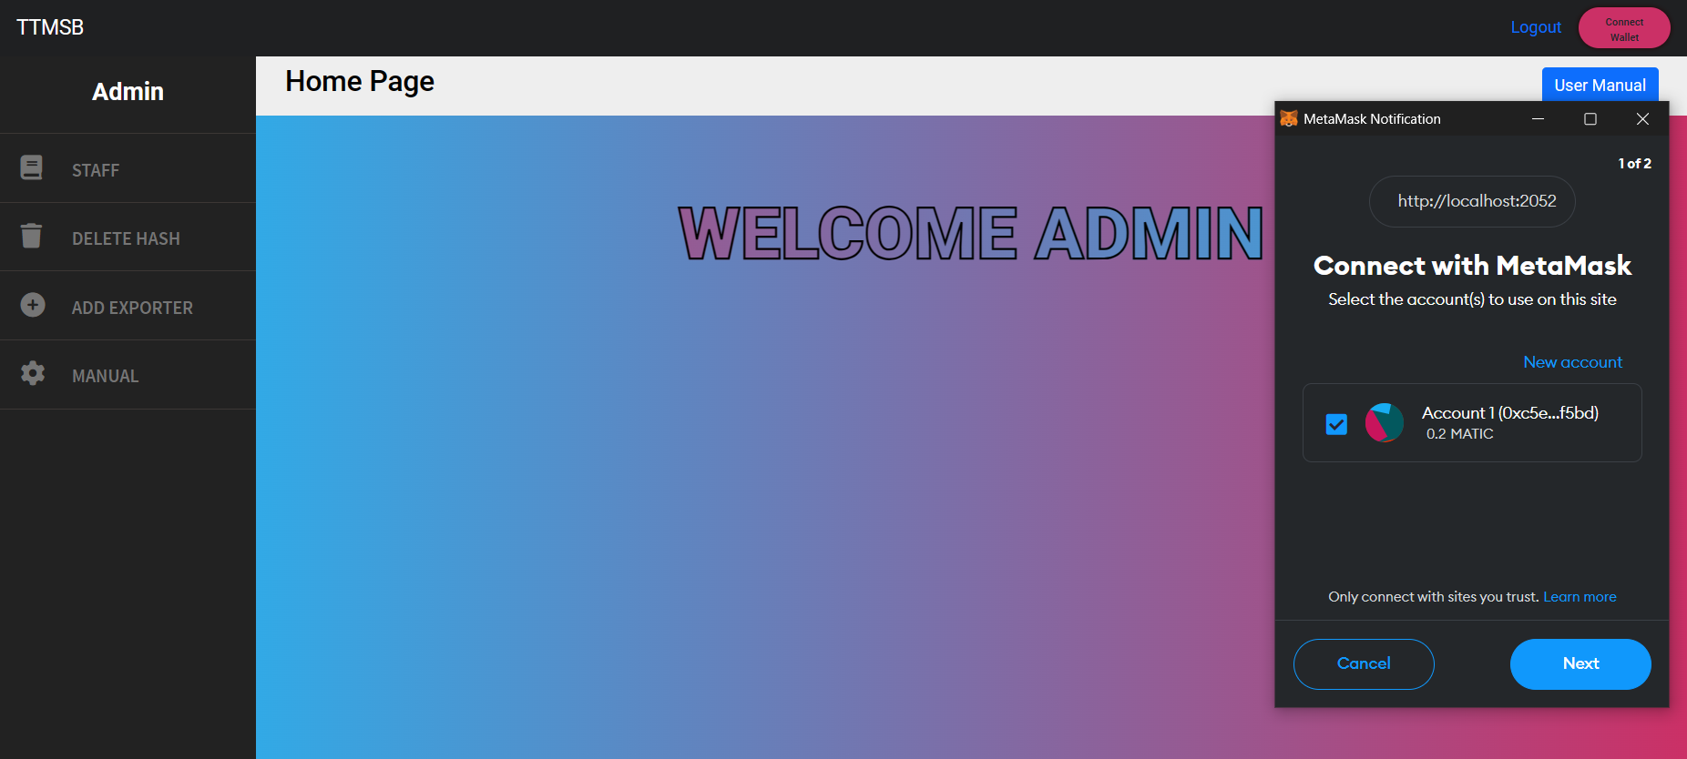

**Click Connect Wallet**

**Connect with the Owner Wallet that register with Smart Contract**

**Manage STAFF**

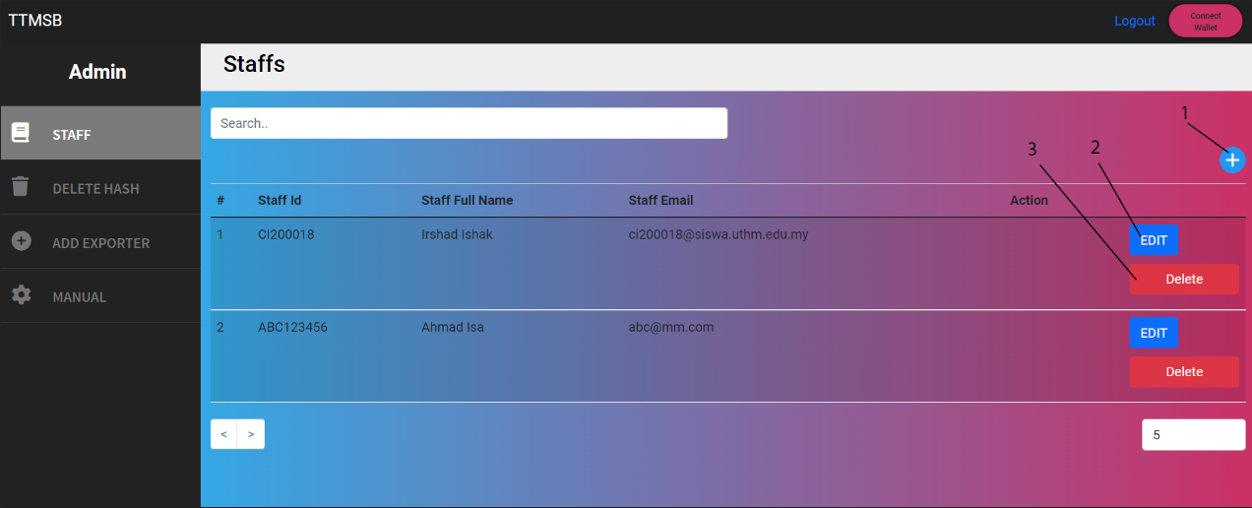

1. **Add Staff**
2. **Edit Staff**
3. **Delete Staff**

**Add STAFF DELETE STAFF**

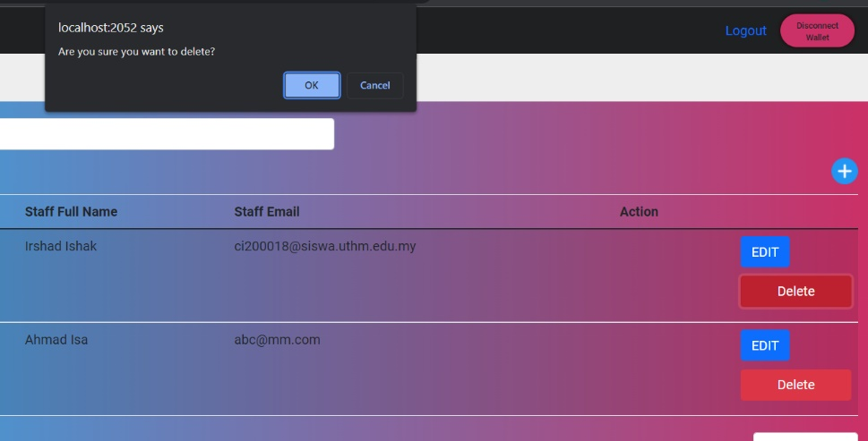 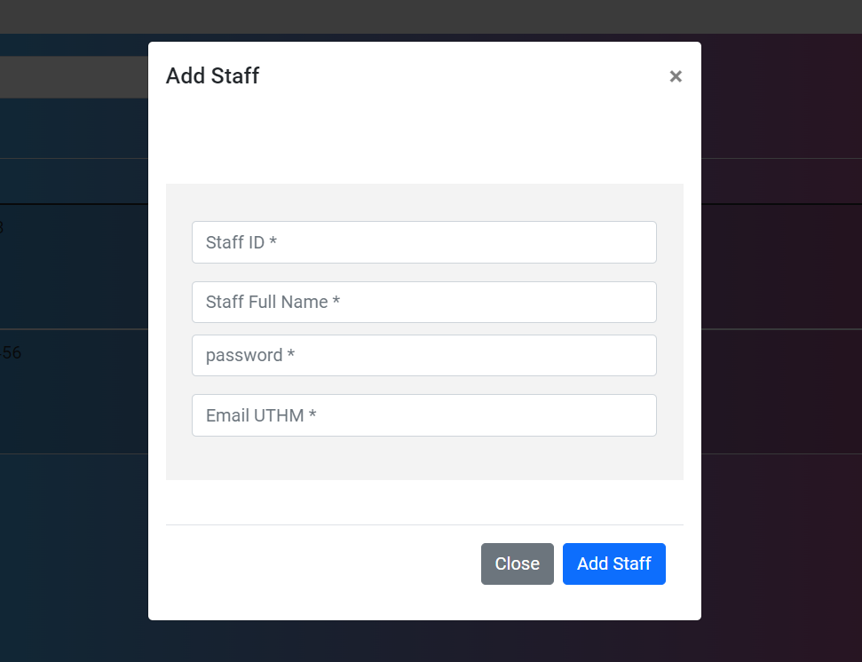

**EDIT STAFF**

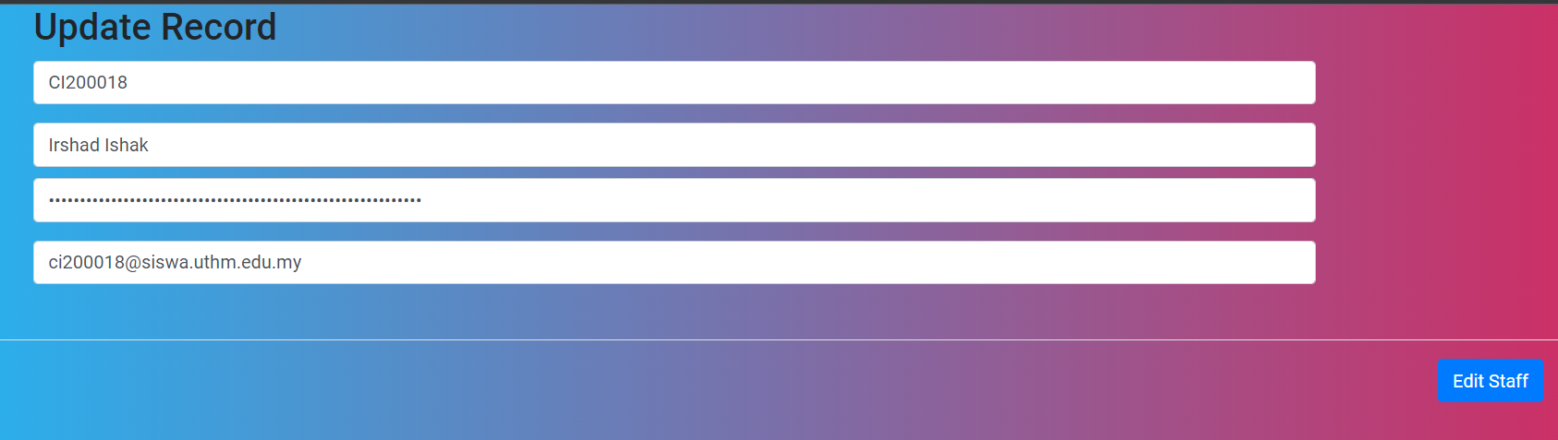

**DELETE HASH TRANSCRIPT**

**Delete Hash Transcript only to delete error of uploading transcript in blockchain and need to clear the hash in the blockchain**

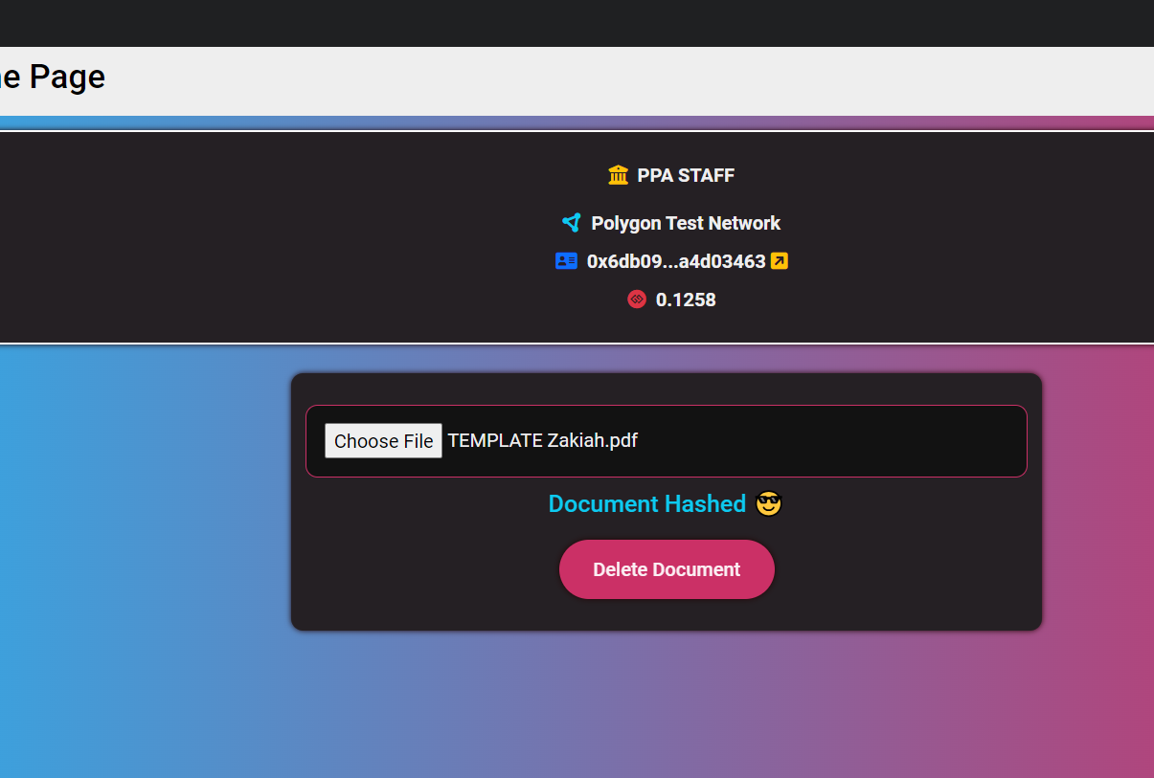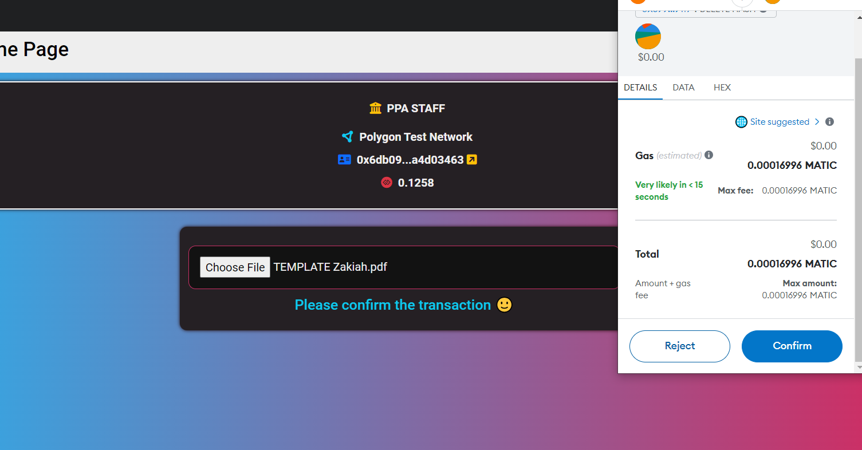

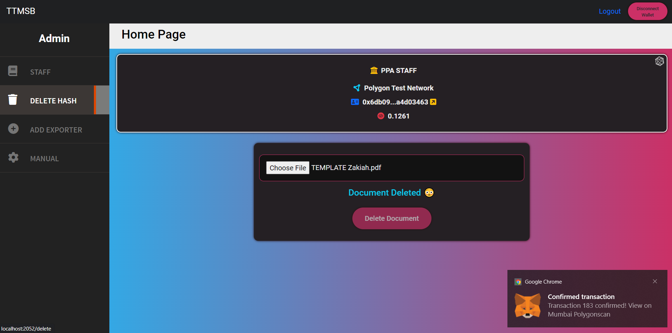

**Upload file that have been upload before to get the same hash with the before**

**Confirm the transaction**

**ADD EXPORTER**

**Exporter is the authority to the another wallet to give permission from owner to have the authority to upload transcript into blockchain. Only the ownership of smart contract can add the exporter.**

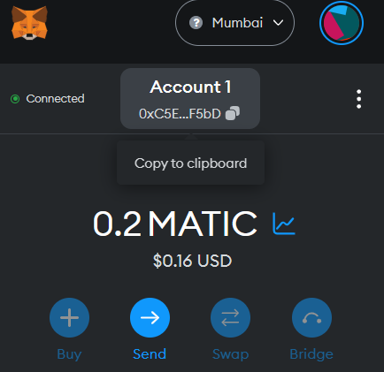

**Copy the other wallet address**

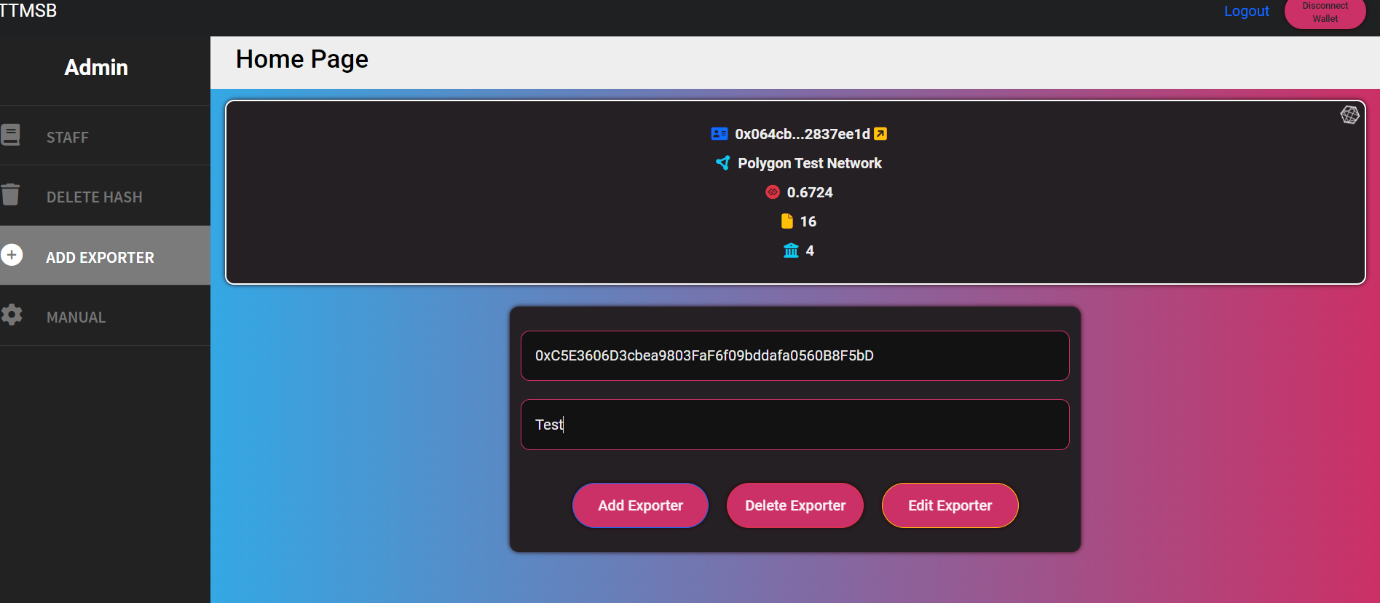

**Paste into the exporter address and name the author**

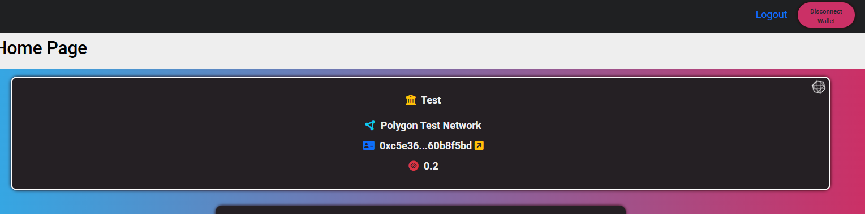

**Accept the transaction and successfully add into the exporter**